Choosing the Right Chart Type
Chart Type | Best For | Looks Like
Column Chart | Comparing values across categories (e.g., total sales by channel) | 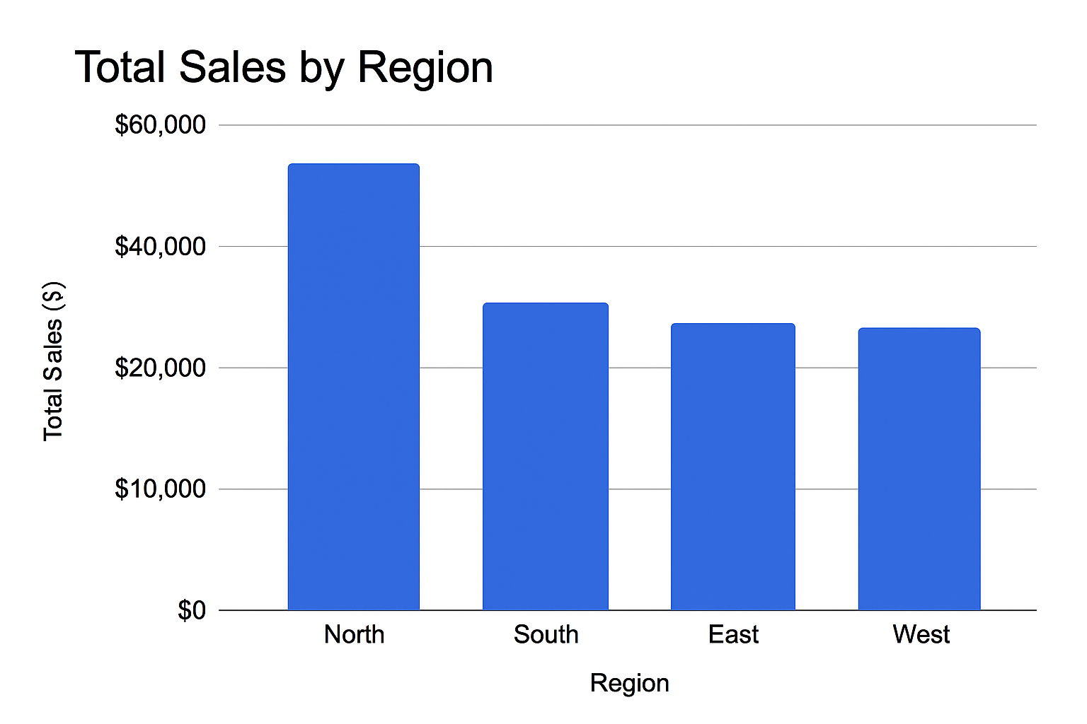
Stacked Column | Showing how sub-groups add up (e.g., new vs. existing customers by campaign) | 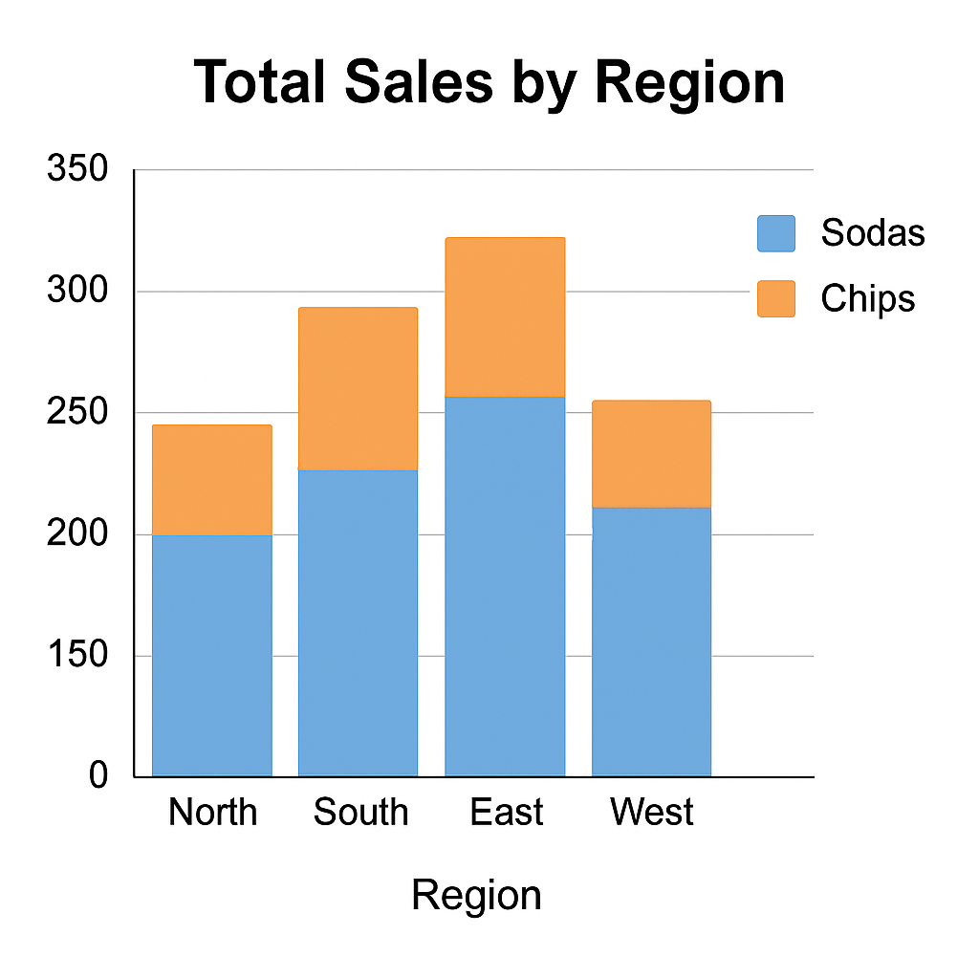
Pie Chart | Showing share of a whole (e.g., percent of total conversions by campaign) | 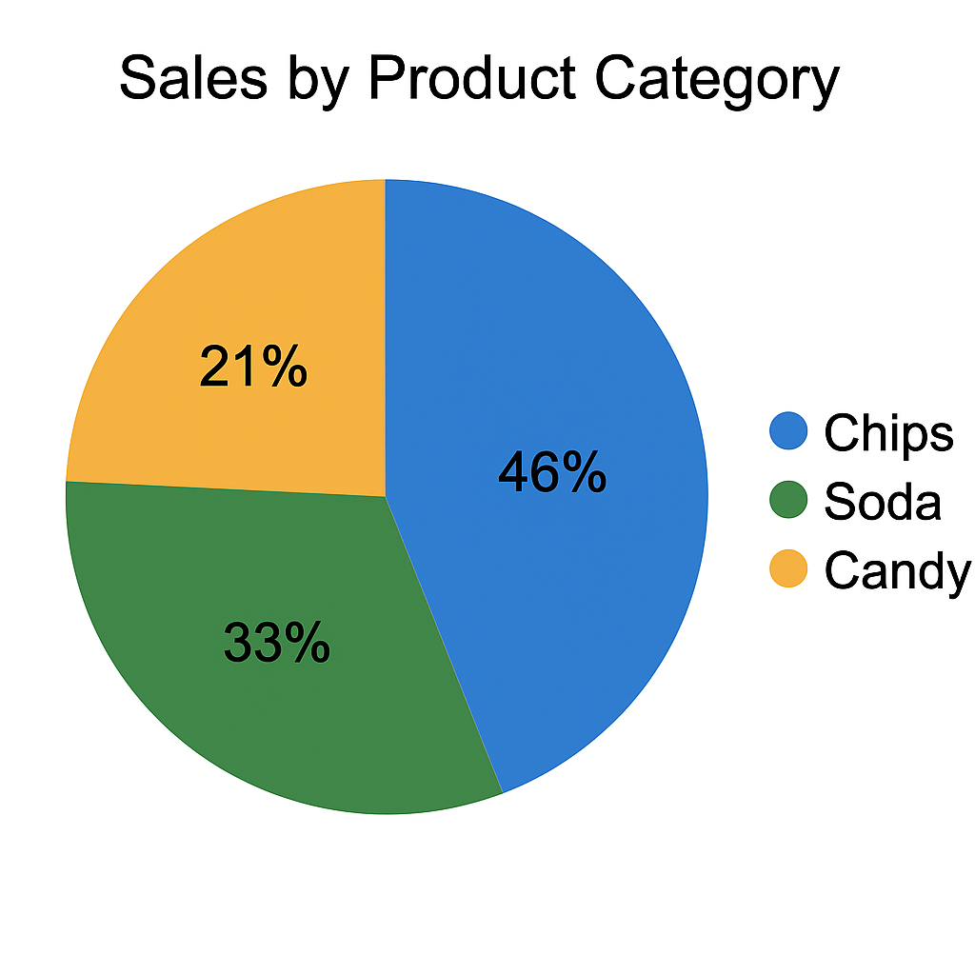
Bar Chart | Same as column, but horizontal—good for long labels | 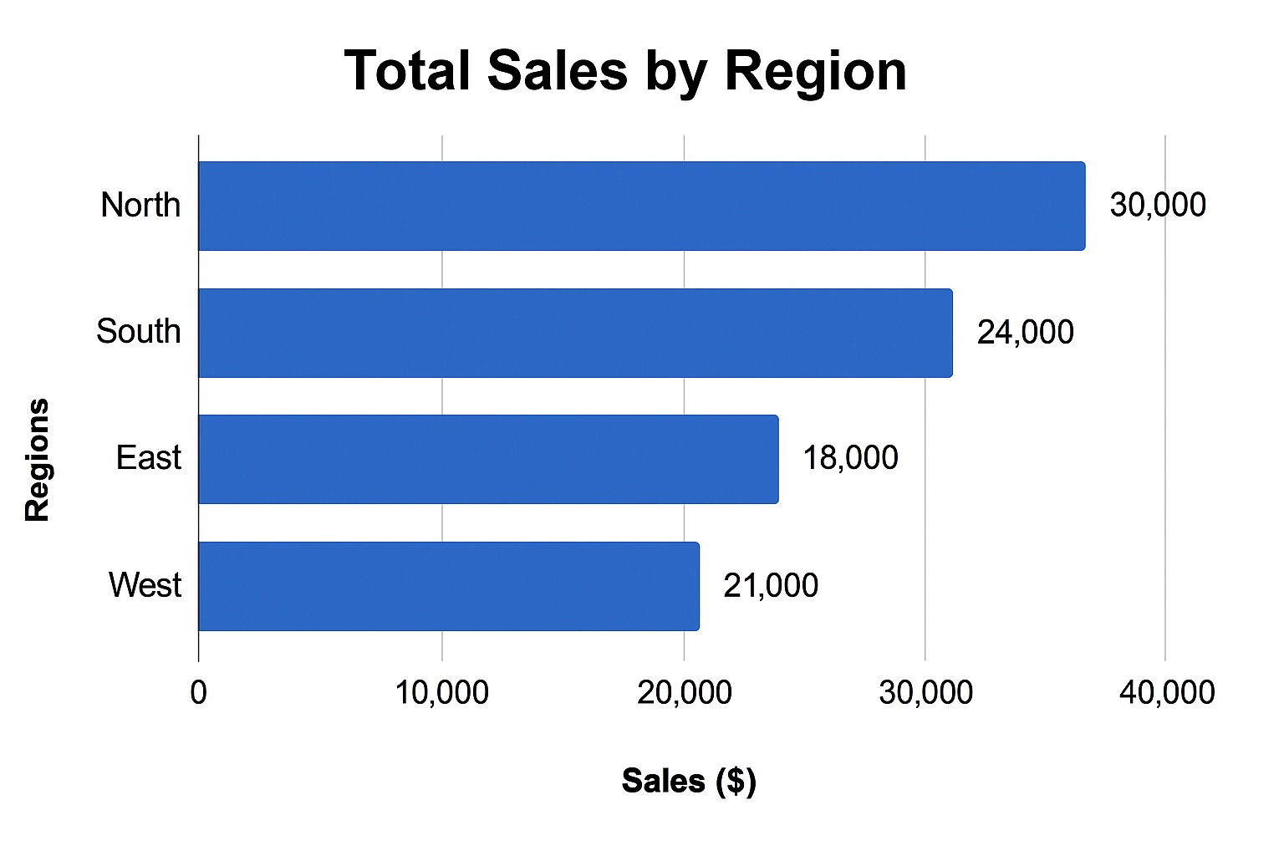

(Tip: Use stacked charts when you care about both totals and how they're made up.)

